SOFTWARE PROJECT REPORT
SMASH Forum Application
Website: http://www2.cs.uregina.ca/~mrd085/Twitter_App/PostList.php

Project Team
Stephen Lerminiaux, INSERT STUDENT #
Mahrukh Aslam, 200385412
Gurinderpal Singh INSERT STUDENT #
Shannon Stinson INSERT STUDENT #
Mathew Dorish INSERT STUDENT #

Project Team
Stephen Lerminiaux, INSERT STUDENT #
Mahrukh Aslam, 200385412
Gurinderpal Singh INSERT STUDENT #
Shannon Stinson INSERT STUDENT #
Mathew Dorish INSERT STUDENT #

1Project TeamWebsite: http://www2.cs.uregina.ca/~mrd085/Twitter_App/PostList.php

Project Team
Stephen Lerminiaux, INSERT STUDENT #
Mahrukh Aslam, 200385412
Gurinderpal Singh INSERT STUDENT #
Shannon Stinson INSERT STUDENT #
Mathew Dorish INSERT STUDENT #

Project Team
Stephen Lerminiaux, INSERT STUDENT #
Mahrukh Aslam, 200385412
Gurinderpal Singh INSERT STUDENT #
Shannon Stinson INSERT STUDENT #
Mathew Dorish INSERT STUDENT #

1Project Team
Stephen Lerminiaux, INSERT STUDENT #
Mahrukh Aslam, 200385412
Gurinderpal Singh INSERT STUDENT #
Shannon Stinson INSERT STUDENT #
Mathew Dorish INSERT STUDENT #

Project Team
Stephen Lerminiaux, INSERT STUDENT #
Mahrukh Aslam, 200385412
Gurinderpal Singh INSERT STUDENT #
Shannon Stinson INSERT STUDENT #
Mathew Dorish INSERT STUDENT #

1
TABLE OF CONTENTS

1

1Project Team
Stephen Lerminiaux, INSERT STUDENT #
Mahrukh Aslam, 200385412
Gurinderpal Singh INSERT STUDENT #
Shannon Stinson INSERT STUDENT #
Mathew Dorish INSERT STUDENT #

Project Team
Stephen Lerminiaux, INSERT STUDENT #
Mahrukh Aslam, 200385412
Gurinderpal Singh INSERT STUDENT #
Shannon Stinson INSERT STUDENT #
Mathew Dorish INSERT STUDENT #

1Project TeamWebsite: http://www2.cs.uregina.ca/~mrd085/Twitter_App/PostList.php

Project Team
Stephen Lerminiaux, INSERT STUDENT #
Mahrukh Aslam, 200385412
Gurinderpal Singh INSERT STUDENT #
Shannon Stinson INSERT STUDENT #
Mathew Dorish INSERT STUDENT #

Project Team
Stephen Lerminiaux, INSERT STUDENT #
Mahrukh Aslam, 200385412
Gurinderpal Singh INSERT STUDENT #
Shannon Stinson INSERT STUDENT #
Mathew Dorish INSERT STUDENT #

1Project TeamWebsite: http://www2.cs.uregina.ca/~mrd085/Twitter_App/PostList.php

Project Team
Stephen Lerminiaux, INSERT STUDENT #
Mahrukh Aslam, 200385412
Gurinderpal Singh INSERT STUDENT #
Shannon Stinson INSERT STUDENT #
Mathew Dorish INSERT STUDENT #

Project Team
Stephen Lerminiaux, INSERT STUDENT #
Mahrukh Aslam, 200385412
Gurinderpal Singh INSERT STUDENT #
Shannon Stinson INSERT STUDENT #
Mathew Dorish INSERT STUDENT #

1Project Team
Stephen Lerminiaux, INSERT STUDENT #
Mahrukh Aslam, 200385412
Gurinderpal Singh INSERT STUDENT #
Shannon Stinson INSERT STUDENT #
Mathew Dorish INSERT STUDENT #

Project Team
Stephen Lerminiaux, INSERT STUDENT #
Mahrukh Aslam, 200385412
Gurinderpal Singh INSERT STUDENT #
Shannon Stinson INSERT STUDENT #
Mathew Dorish INSERT STUDENT #

1
TABLE OF CONTENTS

1

1Project Team
Stephen Lerminiaux, INSERT STUDENT #
Mahrukh Aslam, 200385412
Gurinderpal Singh INSERT STUDENT #
Shannon Stinson INSERT STUDENT #
Mathew Dorish INSERT STUDENT #

Project Team
Stephen Lerminiaux, INSERT STUDENT #
Mahrukh Aslam, 200385412
Gurinderpal Singh INSERT STUDENT #
Shannon Stinson INSERT STUDENT #
Mathew Dorish INSERT STUDENT #

1Project Team
Stephen Lerminiaux, INSERT STUDENT #
Mahrukh Aslam, 200385412
Gurinderpal Singh INSERT STUDENT #
Shannon Stinson INSERT STUDENT #
Mathew Dorish INSERT STUDENT #

Project Team
Stephen Lerminiaux, INSERT STUDENT #
Mahrukh Aslam, 200385412
Gurinderpal Singh INSERT STUDENT #
Shannon Stinson INSERT STUDENT #
Mathew Dorish INSERT STUDENT #

1
TABLE OF CONTENTS

1

1
TABLE OF CONTENTS

1

1
TABLE OF CONTENTS

1

1Project Team
Stephen Lerminiaux, INSERT STUDENT #
Mahrukh Aslam, 200385412
Gurinderpal Singh INSERT STUDENT #
Shannon Stinson INSERT STUDENT #
Mathew Dorish INSERT STUDENT #

Project Team
Stephen Lerminiaux, INSERT STUDENT #
Mahrukh Aslam, 200385412
Gurinderpal Singh INSERT STUDENT #
Shannon Stinson INSERT STUDENT #
Mathew Dorish INSERT STUDENT #

1Project Team
Stephen Lerminiaux, INSERT STUDENT #
Mahrukh Aslam, 200385412
Gurinderpal Singh INSERT STUDENT #
Shannon Stinson INSERT STUDENT #
Mathew Dorish INSERT STUDENT #

Project Team
Stephen Lerminiaux, INSERT STUDENT #
Mahrukh Aslam, 200385412
Gurinderpal Singh INSERT STUDENT #
Shannon Stinson INSERT STUDENT #
Mathew Dorish INSERT STUDENT #

1
TABLE OF CONTENTS

1

1Project Team
Stephen Lerminiaux, INSERT STUDENT #
Mahrukh Aslam, 200385412
Gurinderpal Singh INSERT STUDENT #
Shannon Stinson INSERT STUDENT #
Mathew Dorish INSERT STUDENT #

Project Team
Stephen Lerminiaux, INSERT STUDENT #
Mahrukh Aslam, 200385412
Gurinderpal Singh INSERT STUDENT #
Shannon Stinson INSERT STUDENT #
Mathew Dorish INSERT STUDENT #

1Project TeamWebsite: http://www2.cs.uregina.ca/~mrd085/Twitter_App/PostList.php

Project Team
Stephen Lerminiaux, INSERT STUDENT #
Mahrukh Aslam, 200385412
Gurinderpal Singh INSERT STUDENT #
Shannon Stinson INSERT STUDENT #
Mathew Dorish INSERT STUDENT #

Project Team
Stephen Lerminiaux, INSERT STUDENT #
Mahrukh Aslam, 200385412
Gurinderpal Singh INSERT STUDENT #
Shannon Stinson INSERT STUDENT #
Mathew Dorish INSERT STUDENT #

1Project TeamWebsite: http://www2.cs.uregina.ca/~mrd085/Twitter_App/PostList.php

Project Team
Stephen Lerminiaux, INSERT STUDENT #
Mahrukh Aslam, 200385412
Gurinderpal Singh INSERT STUDENT #
Shannon Stinson INSERT STUDENT #
Mathew Dorish INSERT STUDENT #

Project Team
Stephen Lerminiaux, INSERT STUDENT #
Mahrukh Aslam, 200385412
Gurinderpal Singh INSERT STUDENT #
Shannon Stinson INSERT STUDENT #
Mathew Dorish INSERT STUDENT #

1Project Team
Stephen Lerminiaux, INSERT STUDENT #
Mahrukh Aslam, 200385412
Gurinderpal Singh INSERT STUDENT #
Shannon Stinson INSERT STUDENT #
Mathew Dorish INSERT STUDENT #

Project Team
Stephen Lerminiaux, INSERT STUDENT #
Mahrukh Aslam, 200385412
Gurinderpal Singh INSERT STUDENT #
Shannon Stinson INSERT STUDENT #
Mathew Dorish INSERT STUDENT #

1
TABLE OF CONTENTS

1

1Project Team
Stephen Lerminiaux, INSERT STUDENT #
Mahrukh Aslam, 200385412
Gurinderpal Singh INSERT STUDENT #
Shannon Stinson INSERT STUDENT #
Mathew Dorish INSERT STUDENT #

Project Team
Stephen Lerminiaux, INSERT STUDENT #
Mahrukh Aslam, 200385412
Gurinderpal Singh INSERT STUDENT #
Shannon Stinson INSERT STUDENT #
Mathew Dorish INSERT STUDENT #

1Project TeamWebsite: http://www2.cs.uregina.ca/~mrd085/Twitter_App/PostList.php

Project Team
Stephen Lerminiaux, INSERT STUDENT #
Mahrukh Aslam, 200385412
Gurinderpal Singh INSERT STUDENT #
Shannon Stinson INSERT STUDENT #
Mathew Dorish INSERT STUDENT #

Project Team
Stephen Lerminiaux, INSERT STUDENT #
Mahrukh Aslam, 200385412
Gurinderpal Singh INSERT STUDENT #
Shannon Stinson INSERT STUDENT #
Mathew Dorish INSERT STUDENT #

1Project TeamWebsite: http://www2.cs.uregina.ca/~mrd085/Twitter_App/PostList.php

Project Team
Stephen Lerminiaux, INSERT STUDENT #
Mahrukh Aslam, 200385412
Gurinderpal Singh INSERT STUDENT #
Shannon Stinson INSERT STUDENT #
Mathew Dorish INSERT STUDENT #

Project Team
Stephen Lerminiaux, INSERT STUDENT #
Mahrukh Aslam, 200385412
Gurinderpal Singh INSERT STUDENT #
Shannon Stinson INSERT STUDENT #
Mathew Dorish INSERT STUDENT #

1Project Team
Stephen Lerminiaux, INSERT STUDENT #
Mahrukh Aslam, 200385412
Gurinderpal Singh INSERT STUDENT #
Shannon Stinson INSERT STUDENT #
Mathew Dorish INSERT STUDENT #

Project Team
Stephen Lerminiaux, INSERT STUDENT #
Mahrukh Aslam, 200385412
Gurinderpal Singh INSERT STUDENT #
Shannon Stinson INSERT STUDENT #
Mathew Dorish INSERT STUDENT #

1
TABLE OF CONTENTS

1

1Project Team
Stephen Lerminiaux, INSERT STUDENT #
Mahrukh Aslam, 200385412
Gurinderpal Singh INSERT STUDENT #
Shannon Stinson INSERT STUDENT #
Mathew Dorish INSERT STUDENT #

Project Team
Stephen Lerminiaux, INSERT STUDENT #
Mahrukh Aslam, 200385412
Gurinderpal Singh INSERT STUDENT #
Shannon Stinson INSERT STUDENT #
Mathew Dorish INSERT STUDENT #

1Project Team
Stephen Lerminiaux, INSERT STUDENT #
Mahrukh Aslam, 200385412
Gurinderpal Singh INSERT STUDENT #
Shannon Stinson INSERT STUDENT #
Mathew Dorish INSERT STUDENT #

Project Team
Stephen Lerminiaux, INSERT STUDENT #
Mahrukh Aslam, 200385412
Gurinderpal Singh INSERT STUDENT #
Shannon Stinson INSERT STUDENT #
Mathew Dorish INSERT STUDENT #

1
TABLE OF CONTENTS

1

1
TABLE OF CONTENTS

1

1
TABLE OF CONTENTS

1

1Project Team
Stephen Lerminiaux, INSERT STUDENT #
Mahrukh Aslam, 200385412
Gurinderpal Singh INSERT STUDENT #
Shannon Stinson INSERT STUDENT #
Mathew Dorish INSERT STUDENT #

Project Team
Stephen Lerminiaux, INSERT STUDENT #
Mahrukh Aslam, 200385412
Gurinderpal Singh INSERT STUDENT #
Shannon Stinson INSERT STUDENT #
Mathew Dorish INSERT STUDENT #

1Project Team
Stephen Lerminiaux, INSERT STUDENT #
Mahrukh Aslam, 200385412
Gurinderpal Singh INSERT STUDENT #
Shannon Stinson INSERT STUDENT #
Mathew Dorish INSERT STUDENT #

Project Team
Stephen Lerminiaux, INSERT STUDENT #
Mahrukh Aslam, 200385412
Gurinderpal Singh INSERT STUDENT #
Shannon Stinson INSERT STUDENT #
Mathew Dorish INSERT STUDENT #

1
TABLE OF CONTENTS

1

1Project Team
Stephen Lerminiaux, INSERT STUDENT #
Mahrukh Aslam, 200385412
Gurinderpal Singh INSERT STUDENT #
Shannon Stinson INSERT STUDENT #
Mathew Dorish INSERT STUDENT #

Project Team
Stephen Lerminiaux, INSERT STUDENT #
Mahrukh Aslam, 200385412
Gurinderpal Singh INSERT STUDENT #
Shannon Stinson INSERT STUDENT #
Mathew Dorish INSERT STUDENT #

1Project Team
Stephen Lerminiaux, INSERT STUDENT #
Mahrukh Aslam, 200385412
Gurinderpal Singh INSERT STUDENT #
Shannon Stinson INSERT STUDENT #
Mathew Dorish INSERT STUDENT #

Project Team
Stephen Lerminiaux, INSERT STUDENT #
Mahrukh Aslam, 200385412
Gurinderpal Singh INSERT STUDENT #
Shannon Stinson INSERT STUDENT #
Mathew Dorish INSERT STUDENT #

1
TABLE OF CONTENTS

1

1
TABLE OF CONTENTS

1

1
TABLE OF CONTENTS

1

1
TABLE OF CONTENTS

1

1
TABLE OF CONTENTS

1

1
TABLE OF CONTENTS

1

1
TABLE OF CONTENTS

1

1Project Team
Stephen Lerminiaux, INSERT STUDENT #
Mahrukh Aslam, 200385412
Gurinderpal Singh INSERT STUDENT #
Shannon Stinson INSERT STUDENT #
Mathew Dorish INSERT STUDENT #

Project Team
Stephen Lerminiaux, INSERT STUDENT #
Mahrukh Aslam, 200385412
Gurinderpal Singh INSERT STUDENT #
Shannon Stinson INSERT STUDENT #
Mathew Dorish INSERT STUDENT #

1Project Team
Stephen Lerminiaux, INSERT STUDENT #
Mahrukh Aslam, 200385412
Gurinderpal Singh INSERT STUDENT #
Shannon Stinson INSERT STUDENT #
Mathew Dorish INSERT STUDENT #

Project Team
Stephen Lerminiaux, INSERT STUDENT #
Mahrukh Aslam, 200385412
Gurinderpal Singh INSERT STUDENT #
Shannon Stinson INSERT STUDENT #
Mathew Dorish INSERT STUDENT #

1
TABLE OF CONTENTS

1

1Project Team
Stephen Lerminiaux, INSERT STUDENT #
Mahrukh Aslam, 200385412
Gurinderpal Singh INSERT STUDENT #
Shannon Stinson INSERT STUDENT #
Mathew Dorish INSERT STUDENT #

Project Team
Stephen Lerminiaux, INSERT STUDENT #
Mahrukh Aslam, 200385412
Gurinderpal Singh INSERT STUDENT #
Shannon Stinson INSERT STUDENT #
Mathew Dorish INSERT STUDENT #

1Project Team
Stephen Lerminiaux, INSERT STUDENT #
Mahrukh Aslam, 200385412
Gurinderpal Singh INSERT STUDENT #
Shannon Stinson INSERT STUDENT #
Mathew Dorish INSERT STUDENT #

Project Team
Stephen Lerminiaux, INSERT STUDENT #
Mahrukh Aslam, 200385412
Gurinderpal Singh INSERT STUDENT #
Shannon Stinson INSERT STUDENT #
Mathew Dorish INSERT STUDENT #

1
TABLE OF CONTENTS

1

1
TABLE OF CONTENTS

1

1
TABLE OF CONTENTS

1

1Project Team
Stephen Lerminiaux, INSERT STUDENT #
Mahrukh Aslam, 200385412
Gurinderpal Singh INSERT STUDENT #
Shannon Stinson INSERT STUDENT #
Mathew Dorish INSERT STUDENT #

Project Team
Stephen Lerminiaux, INSERT STUDENT #
Mahrukh Aslam, 200385412
Gurinderpal Singh INSERT STUDENT #
Shannon Stinson INSERT STUDENT #
Mathew Dorish INSERT STUDENT #

1Project Team
Stephen Lerminiaux, INSERT STUDENT #
Mahrukh Aslam, 200385412
Gurinderpal Singh INSERT STUDENT #
Shannon Stinson INSERT STUDENT #
Mathew Dorish INSERT STUDENT #

Project Team
Stephen Lerminiaux, INSERT STUDENT #
Mahrukh Aslam, 200385412
Gurinderpal Singh INSERT STUDENT #
Shannon Stinson INSERT STUDENT #
Mathew Dorish INSERT STUDENT #

1
TABLE OF CONTENTS

1

1Project Team
Stephen Lerminiaux, INSERT STUDENT #
Mahrukh Aslam, 200385412
Gurinderpal Singh INSERT STUDENT #
Shannon Stinson INSERT STUDENT #
Mathew Dorish INSERT STUDENT #

Project Team
Stephen Lerminiaux, INSERT STUDENT #
Mahrukh Aslam, 200385412
Gurinderpal Singh INSERT STUDENT #
Shannon Stinson INSERT STUDENT #
Mathew Dorish INSERT STUDENT #

1Project TeamWebsite: http://www2.cs.uregina.ca/~mrd085/Twitter_App/PostList.php

Project Team
Stephen Lerminiaux, INSERT STUDENT #
Mahrukh Aslam, 200385412
Gurinderpal Singh INSERT STUDENT #
Shannon Stinson INSERT STUDENT #
Mathew Dorish INSERT STUDENT #

Project Team
Stephen Lerminiaux, INSERT STUDENT #
Mahrukh Aslam, 200385412
Gurinderpal Singh INSERT STUDENT #
Shannon Stinson INSERT STUDENT #
Mathew Dorish INSERT STUDENT #

1Project TeamWebsite: http://www2.cs.uregina.ca/~mrd085/Twitter_App/PostList.php

Project Team
Stephen Lerminiaux, INSERT STUDENT #
Mahrukh Aslam, 200385412
Gurinderpal Singh INSERT STUDENT #
Shannon Stinson INSERT STUDENT #
Mathew Dorish INSERT STUDENT #

Project Team
Stephen Lerminiaux, INSERT STUDENT #
Mahrukh Aslam, 200385412
Gurinderpal Singh INSERT STUDENT #
Shannon Stinson INSERT STUDENT #
Mathew Dorish INSERT STUDENT #

1Project Team
Stephen Lerminiaux, INSERT STUDENT #
Mahrukh Aslam, 200385412
Gurinderpal Singh INSERT STUDENT #
Shannon Stinson INSERT STUDENT #
Mathew Dorish INSERT STUDENT #

Project Team
Stephen Lerminiaux, INSERT STUDENT #
Mahrukh Aslam, 200385412
Gurinderpal Singh INSERT STUDENT #
Shannon Stinson INSERT STUDENT #
Mathew Dorish INSERT STUDENT #

1
TABLE OF CONTENTS

1

1Project Team
Stephen Lerminiaux, INSERT STUDENT #
Mahrukh Aslam, 200385412
Gurinderpal Singh INSERT STUDENT #
Shannon Stinson INSERT STUDENT #
Mathew Dorish INSERT STUDENT #

Project Team
Stephen Lerminiaux, INSERT STUDENT #
Mahrukh Aslam, 200385412
Gurinderpal Singh INSERT STUDENT #
Shannon Stinson INSERT STUDENT #
Mathew Dorish INSERT STUDENT #

1Project TeamWebsite: http://www2.cs.uregina.ca/~mrd085/Twitter_App/PostList.php

Project Team
Stephen Lerminiaux, INSERT STUDENT #
Mahrukh Aslam, 200385412
Gurinderpal Singh INSERT STUDENT #
Shannon Stinson INSERT STUDENT #
Mathew Dorish INSERT STUDENT #

Project Team
Stephen Lerminiaux, INSERT STUDENT #
Mahrukh Aslam, 200385412
Gurinderpal Singh INSERT STUDENT #
Shannon Stinson INSERT STUDENT #
Mathew Dorish INSERT STUDENT #

1Project TeamWebsite: http://www2.cs.uregina.ca/~mrd085/Twitter_App/PostList.php

Project Team
Stephen Lerminiaux, INSERT STUDENT #
Mahrukh Aslam, 200385412
Gurinderpal Singh INSERT STUDENT #
Shannon Stinson INSERT STUDENT #
Mathew Dorish INSERT STUDENT #

Project Team
Stephen Lerminiaux, INSERT STUDENT #
Mahrukh Aslam, 200385412
Gurinderpal Singh INSERT STUDENT #
Shannon Stinson INSERT STUDENT #
Mathew Dorish INSERT STUDENT #

1Project Team
Stephen Lerminiaux, INSERT STUDENT #
Mahrukh Aslam, 200385412
Gurinderpal Singh INSERT STUDENT #
Shannon Stinson INSERT STUDENT #
Mathew Dorish INSERT STUDENT #

Project Team
Stephen Lerminiaux, INSERT STUDENT #
Mahrukh Aslam, 200385412
Gurinderpal Singh INSERT STUDENT #
Shannon Stinson INSERT STUDENT #
Mathew Dorish INSERT STUDENT #

1
TABLE OF CONTENTS

1

1Project Team
Stephen Lerminiaux, INSERT STUDENT #
Mahrukh Aslam, 200385412
Gurinderpal Singh INSERT STUDENT #
Shannon Stinson INSERT STUDENT #
Mathew Dorish INSERT STUDENT #

Project Team
Stephen Lerminiaux, INSERT STUDENT #
Mahrukh Aslam, 200385412
Gurinderpal Singh INSERT STUDENT #
Shannon Stinson INSERT STUDENT #
Mathew Dorish INSERT STUDENT #

1Project Team
Stephen Lerminiaux, INSERT STUDENT #
Mahrukh Aslam, 200385412
Gurinderpal Singh INSERT STUDENT #
Shannon Stinson INSERT STUDENT #
Mathew Dorish INSERT STUDENT #

Project Team
Stephen Lerminiaux, INSERT STUDENT #
Mahrukh Aslam, 200385412
Gurinderpal Singh INSERT STUDENT #
Shannon Stinson INSERT STUDENT #
Mathew Dorish INSERT STUDENT #

1
TABLE OF CONTENTS

1

1
TABLE OF CONTENTS

1

1
TABLE OF CONTENTS

1

1Project Team
Stephen Lerminiaux, INSERT STUDENT #
Mahrukh Aslam, 200385412
Gurinderpal Singh INSERT STUDENT #
Shannon Stinson INSERT STUDENT #
Mathew Dorish INSERT STUDENT #

Project Team
Stephen Lerminiaux, INSERT STUDENT #
Mahrukh Aslam, 200385412
Gurinderpal Singh INSERT STUDENT #
Shannon Stinson INSERT STUDENT #
Mathew Dorish INSERT STUDENT #

1Project Team
Stephen Lerminiaux, INSERT STUDENT #
Mahrukh Aslam, 200385412
Gurinderpal Singh INSERT STUDENT #
Shannon Stinson INSERT STUDENT #
Mathew Dorish INSERT STUDENT #

Project Team
Stephen Lerminiaux, INSERT STUDENT #
Mahrukh Aslam, 200385412
Gurinderpal Singh INSERT STUDENT #
Shannon Stinson INSERT STUDENT #
Mathew Dorish INSERT STUDENT #

1
TABLE OF CONTENTS

1

1Project Team
Stephen Lerminiaux, INSERT STUDENT #
Mahrukh Aslam, 200385412
Gurinderpal Singh INSERT STUDENT #
Shannon Stinson INSERT STUDENT #
Mathew Dorish INSERT STUDENT #

Project Team
Stephen Lerminiaux, INSERT STUDENT #
Mahrukh Aslam, 200385412
Gurinderpal Singh INSERT STUDENT #
Shannon Stinson INSERT STUDENT #
Mathew Dorish INSERT STUDENT #

1Project TeamWebsite: http://www2.cs.uregina.ca/~mrd085/Twitter_App/PostList.php

Project Team
Stephen Lerminiaux, INSERT STUDENT #
Mahrukh Aslam, 200385412
Gurinderpal Singh INSERT STUDENT #
Shannon Stinson INSERT STUDENT #
Mathew Dorish INSERT STUDENT #

Project Team
Stephen Lerminiaux, INSERT STUDENT #
Mahrukh Aslam, 200385412
Gurinderpal Singh INSERT STUDENT #
Shannon Stinson INSERT STUDENT #
Mathew Dorish INSERT STUDENT #

1Project TeamWebsite: http://www2.cs.uregina.ca/~mrd085/Twitter_App/PostList.php

Project Team
Stephen Lerminiaux, INSERT STUDENT #
Mahrukh Aslam, 200385412
Gurinderpal Singh INSERT STUDENT #
Shannon Stinson INSERT STUDENT #
Mathew Dorish INSERT STUDENT #

Project Team
Stephen Lerminiaux, INSERT STUDENT #
Mahrukh Aslam, 200385412
Gurinderpal Singh INSERT STUDENT #
Shannon Stinson INSERT STUDENT #
Mathew Dorish INSERT STUDENT #

1Project Team
Stephen Lerminiaux, INSERT STUDENT #
Mahrukh Aslam, 200385412
Gurinderpal Singh INSERT STUDENT #
Shannon Stinson INSERT STUDENT #
Mathew Dorish INSERT STUDENT #

Project Team
Stephen Lerminiaux, INSERT STUDENT #
Mahrukh Aslam, 200385412
Gurinderpal Singh INSERT STUDENT #
Shannon Stinson INSERT STUDENT #
Mathew Dorish INSERT STUDENT #

1
TABLE OF CONTENTS

1

1Project Team
Stephen Lerminiaux, INSERT STUDENT #
Mahrukh Aslam, 200385412
Gurinderpal Singh INSERT STUDENT #
Shannon Stinson INSERT STUDENT #
Mathew Dorish INSERT STUDENT #

Project Team
Stephen Lerminiaux, INSERT STUDENT #
Mahrukh Aslam, 200385412
Gurinderpal Singh INSERT STUDENT #
Shannon Stinson INSERT STUDENT #
Mathew Dorish INSERT STUDENT #

1Project TeamWebsite: http://www2.cs.uregina.ca/~mrd085/Twitter_App/PostList.php

Project Team
Stephen Lerminiaux, INSERT STUDENT #
Mahrukh Aslam, 200385412
Gurinderpal Singh INSERT STUDENT #
Shannon Stinson INSERT STUDENT #
Mathew Dorish INSERT STUDENT #

Project Team
Stephen Lerminiaux, INSERT STUDENT #
Mahrukh Aslam, 200385412
Gurinderpal Singh INSERT STUDENT #
Shannon Stinson INSERT STUDENT #
Mathew Dorish INSERT STUDENT #

1Project TeamWebsite: http://www2.cs.uregina.ca/~mrd085/Twitter_App/PostList.php





Project Team
Stephen Lerminiaux, 200234860
Mahrukh Aslam, 200385412
Gurinderpal Singh, INSERT STUDENT #
Shannon Stinson, 200251488
Mathew Dorish, 200393045

Project Team
Stephen Lerminiaux, INSERT STUDENT #
Mahrukh Aslam, 200385412
Gurinderpal Singh INSERT STUDENT #
Shannon Stinson INSERT STUDENT #
Mathew Dorish INSERT STUDENT #

1Project Team
Stephen Lerminiaux, INSERT STUDENT #
Mahrukh Aslam, 200385412
Gurinderpal Singh INSERT STUDENT #
Shannon Stinson INSERT STUDENT #
Mathew Dorish INSERT STUDENT #

Project Team
Stephen Lerminiaux, INSERT STUDENT #
Mahrukh Aslam, 200385412
Gurinderpal Singh INSERT STUDENT #
Shannon Stinson INSERT STUDENT #
Mathew Dorish INSERT STUDENT #

1
TABLE OF CONTENTS

1

1Project Team
Stephen Lerminiaux, INSERT STUDENT #
Mahrukh Aslam, 200385412
Gurinderpal Singh INSERT STUDENT #
Shannon Stinson INSERT STUDENT #
Mathew Dorish INSERT STUDENT #

Project Team
Stephen Lerminiaux, INSERT STUDENT #
Mahrukh Aslam, 200385412
Gurinderpal Singh INSERT STUDENT #
Shannon Stinson INSERT STUDENT #
Mathew Dorish INSERT STUDENT #

1Project Team
Stephen Lerminiaux, INSERT STUDENT #
Mahrukh Aslam, 200385412
Gurinderpal Singh INSERT STUDENT #
Shannon Stinson INSERT STUDENT #
Mathew Dorish INSERT STUDENT #

Project Team
Stephen Lerminiaux, INSERT STUDENT #
Mahrukh Aslam, 200385412
Gurinderpal Singh INSERT STUDENT #
Shannon Stinson INSERT STUDENT #
Mathew Dorish INSERT STUDENT #

1
TABLE OF CONTENTS

1

1
TABLE OF CONTENTS

1

1
TABLE OF CONTENTS

1

1Project Team
Stephen Lerminiaux, INSERT STUDENT #
Mahrukh Aslam, 200385412
Gurinderpal Singh INSERT STUDENT #
Shannon Stinson INSERT STUDENT #
Mathew Dorish INSERT STUDENT #

Project Team
Stephen Lerminiaux, INSERT STUDENT #
Mahrukh Aslam, 200385412
Gurinderpal Singh INSERT STUDENT #
Shannon Stinson INSERT STUDENT #
Mathew Dorish INSERT STUDENT #

1Project Team
Stephen Lerminiaux, INSERT STUDENT #
Mahrukh Aslam, 200385412
Gurinderpal Singh INSERT STUDENT #
Shannon Stinson INSERT STUDENT #
Mathew Dorish INSERT STUDENT #

Project Team
Stephen Lerminiaux, INSERT STUDENT #
Mahrukh Aslam, 200385412
Gurinderpal Singh INSERT STUDENT #
Shannon Stinson INSERT STUDENT #
Mathew Dorish INSERT STUDENT #

1
TABLE OF CONTENTS

1

1Project Team
Stephen Lerminiaux, INSERT STUDENT #
Mahrukh Aslam, 200385412
Gurinderpal Singh INSERT STUDENT #
Shannon Stinson INSERT STUDENT #
Mathew Dorish INSERT STUDENT #

Project Team
Stephen Lerminiaux, INSERT STUDENT #
Mahrukh Aslam, 200385412
Gurinderpal Singh INSERT STUDENT #
Shannon Stinson INSERT STUDENT #
Mathew Dorish INSERT STUDENT #

1Project Team
Stephen Lerminiaux, INSERT STUDENT #
Mahrukh Aslam, 200385412
Gurinderpal Singh INSERT STUDENT #
Shannon Stinson INSERT STUDENT #
Mathew Dorish INSERT STUDENT #

Project Team
Stephen Lerminiaux, INSERT STUDENT #
Mahrukh Aslam, 200385412
Gurinderpal Singh INSERT STUDENT #
Shannon Stinson INSERT STUDENT #
Mathew Dorish INSERT STUDENT #

1
TABLE OF CONTENTS

1

1
TABLE OF CONTENTS

1

1
TABLE OF CONTENTS

1

1
TABLE OF CONTENTS

1

1
TABLE OF CONTENTS

1

1
TABLE OF CONTENTS

1

1
TABLE OF CONTENTS

1

1Project Team
Stephen Lerminiaux, INSERT STUDENT #
Mahrukh Aslam, 200385412
Gurinderpal Singh INSERT STUDENT #
Shannon Stinson INSERT STUDENT #
Mathew Dorish INSERT STUDENT #

Project Team
Stephen Lerminiaux, INSERT STUDENT #
Mahrukh Aslam, 200385412
Gurinderpal Singh INSERT STUDENT #
Shannon Stinson INSERT STUDENT #
Mathew Dorish INSERT STUDENT #

1Project Team
Stephen Lerminiaux, INSERT STUDENT #
Mahrukh Aslam, 200385412
Gurinderpal Singh INSERT STUDENT #
Shannon Stinson INSERT STUDENT #
Mathew Dorish INSERT STUDENT #

Project Team
Stephen Lerminiaux, INSERT STUDENT #
Mahrukh Aslam, 200385412
Gurinderpal Singh INSERT STUDENT #
Shannon Stinson INSERT STUDENT #
Mathew Dorish INSERT STUDENT #

1
TABLE OF CONTENTS

1

1Project Team
Stephen Lerminiaux, INSERT STUDENT #
Mahrukh Aslam, 200385412
Gurinderpal Singh INSERT STUDENT #
Shannon Stinson INSERT STUDENT #
Mathew Dorish INSERT STUDENT #

Project Team
Stephen Lerminiaux, INSERT STUDENT #
Mahrukh Aslam, 200385412
Gurinderpal Singh INSERT STUDENT #
Shannon Stinson INSERT STUDENT #
Mathew Dorish INSERT STUDENT #

1Project Team
Stephen Lerminiaux, INSERT STUDENT #
Mahrukh Aslam, 200385412
Gurinderpal Singh INSERT STUDENT #
Shannon Stinson INSERT STUDENT #
Mathew Dorish INSERT STUDENT #

Project Team
Stephen Lerminiaux, INSERT STUDENT #
Mahrukh Aslam, 200385412
Gurinderpal Singh INSERT STUDENT #
Shannon Stinson INSERT STUDENT #
Mathew Dorish INSERT STUDENT #

1
TABLE OF CONTENTS

1

1
TABLE OF CONTENTS

1

1
TABLE OF CONTENTS

1

1Project Team
Stephen Lerminiaux, INSERT STUDENT #
Mahrukh Aslam, 200385412
Gurinderpal Singh INSERT STUDENT #
Shannon Stinson INSERT STUDENT #
Mathew Dorish INSERT STUDENT #

Project Team
Stephen Lerminiaux, INSERT STUDENT #
Mahrukh Aslam, 200385412
Gurinderpal Singh INSERT STUDENT #
Shannon Stinson INSERT STUDENT #
Mathew Dorish INSERT STUDENT #

1Project Team
Stephen Lerminiaux, INSERT STUDENT #
Mahrukh Aslam, 200385412
Gurinderpal Singh INSERT STUDENT #
Shannon Stinson INSERT STUDENT #
Mathew Dorish INSERT STUDENT #

Project Team
Stephen Lerminiaux, INSERT STUDENT #
Mahrukh Aslam, 200385412
Gurinderpal Singh INSERT STUDENT #
Shannon Stinson INSERT STUDENT #
Mathew Dorish INSERT STUDENT #

1
TABLE OF CONTENTS

1

1Project Team
Stephen Lerminiaux, INSERT STUDENT #
Mahrukh Aslam, 200385412
Gurinderpal Singh INSERT STUDENT #
Shannon Stinson INSERT STUDENT #
Mathew Dorish INSERT STUDENT #

Project Team
Stephen Lerminiaux, INSERT STUDENT #
Mahrukh Aslam, 200385412
Gurinderpal Singh INSERT STUDENT #
Shannon Stinson INSERT STUDENT #
Mathew Dorish INSERT STUDENT #

1Project Team
Stephen Lerminiaux, INSERT STUDENT #
Mahrukh Aslam, 200385412
Gurinderpal Singh INSERT STUDENT #
Shannon Stinson INSERT STUDENT #
Mathew Dorish INSERT STUDENT #

Project Team
Stephen Lerminiaux, INSERT STUDENT #
Mahrukh Aslam, 200385412
Gurinderpal Singh INSERT STUDENT #
Shannon Stinson INSERT STUDENT #
Mathew Dorish INSERT STUDENT #

1
TABLE OF CONTENTS

1

1
TABLE OF CONTENTS

1

1
TABLE OF CONTENTS

1

1
TABLE OF CONTENTS

1

1
TABLE OF CONTENTS

1

1
TABLE OF CONTENTS

1

1
TABLE OF CONTENTS

1

1
TABLE OF CONTENTS

1

1
TABLE OF CONTENTS

1

1
TABLE OF CONTENTS

1

1
TABLE OF CONTENTS

1

1
TABLE OF CONTENTS

1

1
TABLE OF CONTENTS

1

1
TABLE OF CONTENTS

1

1
TABLE OF CONTENTS

1

1Project Team
Stephen Lerminiaux, INSERT STUDENT #
Mahrukh Aslam, 200385412
Gurinderpal Singh INSERT STUDENT #
Shannon Stinson INSERT STUDENT #
Mathew Dorish INSERT STUDENT #

Project Team
Stephen Lerminiaux, INSERT STUDENT #
Mahrukh Aslam, 200385412
Gurinderpal Singh INSERT STUDENT #
Shannon Stinson INSERT STUDENT #
Mathew Dorish INSERT STUDENT #

1Project Team
Stephen Lerminiaux, INSERT STUDENT #
Mahrukh Aslam, 200385412
Gurinderpal Singh INSERT STUDENT #
Shannon Stinson INSERT STUDENT #
Mathew Dorish INSERT STUDENT #

Project Team
Stephen Lerminiaux, INSERT STUDENT #
Mahrukh Aslam, 200385412
Gurinderpal Singh INSERT STUDENT #
Shannon Stinson INSERT STUDENT #
Mathew Dorish INSERT STUDENT #

1
TABLE OF CONTENTS

1

1Project Team
Stephen Lerminiaux, INSERT STUDENT #
Mahrukh Aslam, 200385412
Gurinderpal Singh INSERT STUDENT #
Shannon Stinson INSERT STUDENT #
Mathew Dorish INSERT STUDENT #

Project Team
Stephen Lerminiaux, INSERT STUDENT #
Mahrukh Aslam, 200385412
Gurinderpal Singh INSERT STUDENT #
Shannon Stinson INSERT STUDENT #
Mathew Dorish INSERT STUDENT #

1Project Team
Stephen Lerminiaux, INSERT STUDENT #
Mahrukh Aslam, 200385412
Gurinderpal Singh INSERT STUDENT #
Shannon Stinson INSERT STUDENT #
Mathew Dorish INSERT STUDENT #

Project Team
Stephen Lerminiaux, INSERT STUDENT #
Mahrukh Aslam, 200385412
Gurinderpal Singh INSERT STUDENT #
Shannon Stinson INSERT STUDENT #
Mathew Dorish INSERT STUDENT #

1
TABLE OF CONTENTS

1

1
TABLE OF CONTENTS

1

1
TABLE OF CONTENTS

1

1Project Team
Stephen Lerminiaux, INSERT STUDENT #
Mahrukh Aslam, 200385412
Gurinderpal Singh INSERT STUDENT #
Shannon Stinson INSERT STUDENT #
Mathew Dorish INSERT STUDENT #

Project Team
Stephen Lerminiaux, INSERT STUDENT #
Mahrukh Aslam, 200385412
Gurinderpal Singh INSERT STUDENT #
Shannon Stinson INSERT STUDENT #
Mathew Dorish INSERT STUDENT #

1Project Team
Stephen Lerminiaux, INSERT STUDENT #
Mahrukh Aslam, 200385412
Gurinderpal Singh INSERT STUDENT #
Shannon Stinson INSERT STUDENT #
Mathew Dorish INSERT STUDENT #

Project Team
Stephen Lerminiaux, INSERT STUDENT #
Mahrukh Aslam, 200385412
Gurinderpal Singh INSERT STUDENT #
Shannon Stinson INSERT STUDENT #
Mathew Dorish INSERT STUDENT #

1
TABLE OF CONTENTS

1

1Project Team
Stephen Lerminiaux, INSERT STUDENT #
Mahrukh Aslam, 200385412
Gurinderpal Singh INSERT STUDENT #
Shannon Stinson INSERT STUDENT #
Mathew Dorish INSERT STUDENT #

Project Team
Stephen Lerminiaux, INSERT STUDENT #
Mahrukh Aslam, 200385412
Gurinderpal Singh INSERT STUDENT #
Shannon Stinson INSERT STUDENT #
Mathew Dorish INSERT STUDENT #

1Project Team
Stephen Lerminiaux, INSERT STUDENT #
Mahrukh Aslam, 200385412
Gurinderpal Singh INSERT STUDENT #
Shannon Stinson INSERT STUDENT #
Mathew Dorish INSERT STUDENT #

Project Team
Stephen Lerminiaux, INSERT STUDENT #
Mahrukh Aslam, 200385412
Gurinderpal Singh INSERT STUDENT #
Shannon Stinson INSERT STUDENT #
Mathew Dorish INSERT STUDENT #

1
TABLE OF CONTENTS

1

1
TABLE OF CONTENTS

1

1
TABLE OF CONTENTS

1

1
TABLE OF CONTENTS

1

1
TABLE OF CONTENTS

1

1
TABLE OF CONTENTS

1

1
TABLE OF CONTENTS

1

1Project Team
Stephen Lerminiaux, INSERT STUDENT #
Mahrukh Aslam, 200385412
Gurinderpal Singh INSERT STUDENT #
Shannon Stinson INSERT STUDENT #
Mathew Dorish INSERT STUDENT #

Project Team
Stephen Lerminiaux, INSERT STUDENT #
Mahrukh Aslam, 200385412
Gurinderpal Singh INSERT STUDENT #
Shannon Stinson INSERT STUDENT #
Mathew Dorish INSERT STUDENT #

1Project Team
Stephen Lerminiaux, INSERT STUDENT #
Mahrukh Aslam, 200385412
Gurinderpal Singh INSERT STUDENT #
Shannon Stinson INSERT STUDENT #
Mathew Dorish INSERT STUDENT #

Project Team
Stephen Lerminiaux, INSERT STUDENT #
Mahrukh Aslam, 200385412
Gurinderpal Singh INSERT STUDENT #
Shannon Stinson INSERT STUDENT #
Mathew Dorish INSERT STUDENT #

1
TABLE OF CONTENTS

1

1Project Team
Stephen Lerminiaux, INSERT STUDENT #
Mahrukh Aslam, 200385412
Gurinderpal Singh INSERT STUDENT #
Shannon Stinson INSERT STUDENT #
Mathew Dorish INSERT STUDENT #

Project Team
Stephen Lerminiaux, INSERT STUDENT #
Mahrukh Aslam, 200385412
Gurinderpal Singh INSERT STUDENT #
Shannon Stinson INSERT STUDENT #
Mathew Dorish INSERT STUDENT #

1Project Team
Stephen Lerminiaux, INSERT STUDENT #
Mahrukh Aslam, 200385412
Gurinderpal Singh INSERT STUDENT #
Shannon Stinson INSERT STUDENT #
Mathew Dorish INSERT STUDENT #

Project Team
Stephen Lerminiaux, INSERT STUDENT #
Mahrukh Aslam, 200385412
Gurinderpal Singh INSERT STUDENT #
Shannon Stinson INSERT STUDENT #
Mathew Dorish INSERT STUDENT #

1
TABLE OF CONTENTS

1

1
TABLE OF CONTENTS

1

1
TABLE OF CONTENTS

1

1Project Team
Stephen Lerminiaux, INSERT STUDENT #
Mahrukh Aslam, 200385412
Gurinderpal Singh INSERT STUDENT #
Shannon Stinson INSERT STUDENT #
Mathew Dorish INSERT STUDENT #

Project Team
Stephen Lerminiaux, INSERT STUDENT #
Mahrukh Aslam, 200385412
Gurinderpal Singh INSERT STUDENT #
Shannon Stinson INSERT STUDENT #
Mathew Dorish INSERT STUDENT #

1Project Team
Stephen Lerminiaux, INSERT STUDENT #
Mahrukh Aslam, 200385412
Gurinderpal Singh INSERT STUDENT #
Shannon Stinson INSERT STUDENT #
Mathew Dorish INSERT STUDENT #

Project Team
Stephen Lerminiaux, INSERT STUDENT #
Mahrukh Aslam, 200385412
Gurinderpal Singh INSERT STUDENT #
Shannon Stinson INSERT STUDENT #
Mathew Dorish INSERT STUDENT #

1
TABLE OF CONTENTS

1

1Project Team
Stephen Lerminiaux, INSERT STUDENT #
Mahrukh Aslam, 200385412
Gurinderpal Singh INSERT STUDENT #
Shannon Stinson INSERT STUDENT #
Mathew Dorish INSERT STUDENT #

Project Team
Stephen Lerminiaux, INSERT STUDENT #
Mahrukh Aslam, 200385412
Gurinderpal Singh INSERT STUDENT #
Shannon Stinson INSERT STUDENT #
Mathew Dorish INSERT STUDENT #

1Project Team
Stephen Lerminiaux, INSERT STUDENT #
Mahrukh Aslam, 200385412
Gurinderpal Singh INSERT STUDENT #
Shannon Stinson INSERT STUDENT #
Mathew Dorish INSERT STUDENT #

Project Team
Stephen Lerminiaux, INSERT STUDENT #
Mahrukh Aslam, 200385412
Gurinderpal Singh INSERT STUDENT #
Shannon Stinson INSERT STUDENT #
Mathew Dorish INSERT STUDENT #




1
TABLE OF CONTENTS

1

1
TABLE OF CONTENTS

1

1
TABLE OF CONTENTS

1

1
TABLE OF CONTENTS

1

1
TABLE OF CONTENTS

1

1
TABLE OF CONTENTS

1

1
TABLE OF CONTENTS

1

1
TABLE OF CONTENTS

1

1
TABLE OF CONTENTS

1

1
TABLE OF CONTENTS

1

1
TABLE OF CONTENTS

1

1
TABLE OF CONTENTS

1

1
TABLE OF CONTENTS

1

1
TABLE OF CONTENTS

1

1
TABLE OF CONTENTS

1

1
TABLE OF CONTENTS

1

1
TABLE OF CONTENTS

1

1
TABLE OF CONTENTS

1

1
TABLE OF CONTENTS

1

1
TABLE OF CONTENTS

1

1
TABLE OF CONTENTS

1

1
TABLE OF CONTENTS

1

1
TABLE OF CONTENTS

1

1
TABLE OF CONTENTS

1

1
TABLE OF CONTENTS

1

1
TABLE OF CONTENTS

1

1
TABLE OF CONTENTS

1

1
TABLE OF CONTENTS

1

1
TABLE OF CONTENTS

1

1
TABLE OF CONTENTS

1

1
TABLE OF CONTENTS

1

1
TABLE OF CONTENTS

1

1. PROBLEM DEFINITION 2

2. SOFTWARE REQUIREMENTS 3
2.1 Use Case Diagram 3
2.2 Use Cases Description 4
2.3 Software Qualities 4
3. DESIGN SPECIFICATION 5
3.1 Software Architecture 5
3.2 Sequence Diagrams 6
3.3 Class Diagrams 8
3.4 Object Diagrams 9
4. CODE DESCRIPTION 10
4.1 Component Diagram 10
4.2 Deployment Diagram 11
4.3 Classes and Functions Implemented 11
4.4 Website URL 11
5. TECHINICAL REQUIREMENTS 12
5.1 UML Supporting Tool 12
5.2 Programming Languages 12
5.3 Reused Algorithms and Programs 12
5.4 Software Tools and Environments 13
5.5 Database Management Systems 13
6. USER DOCUMENTATION 15
7. CODE TESTING 22
7.1 Correctness Testing 22
7.2 Robustness Testing 28
7.3 Performance Testing 29
8. MEMBER CONTRIBUTIONS 31

1. PROBLEM
DEFINITION

Our customers requested a web application which behaves as a social media platform where users can create, view, and vote on posts. Ideally, our users would be able to create an account and be able to manage their profile and posts. Users can then communicate with their friends and share ideas on this platform.


Source: http://www.parlevelsystems.com/wp-content/uploads/2013/08/Vendor-Relations.jpg

2. SOFTWARE
REQUIREMENTS

2.1 Use Case Diagram

The image below is the use case diagram that consists of all use cases and actors that were used in our software project.

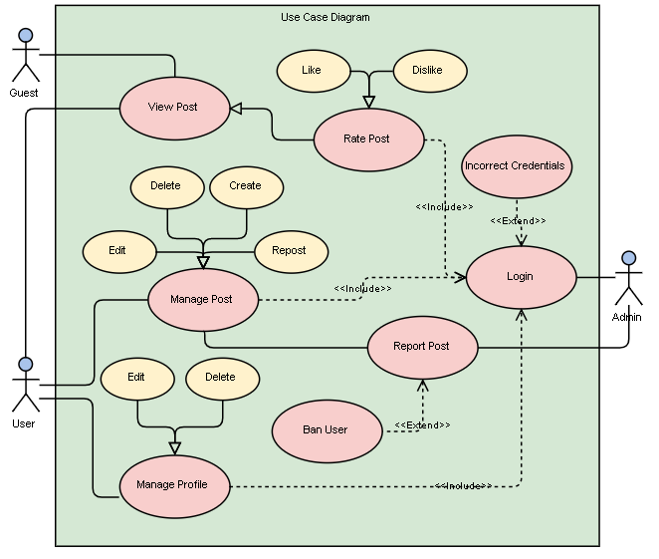

2.2 Use Cases Description

- Creating a post: Users who are logged in can create a post with a maximum of 250 characters and have it displayed on the post list page. A dynamic counter character is used to display the number of characters that have been written. Users are not permitted to submit the post if they exceed the limit and are provided with an error message. Created posts have both front-end and back-end validation to prevent security issues.

- Viewing a post: The created posts are displayed on the post list page. Users are redirected to the post list page after a successful login. Users are able to view the most recent 20 posts on each page and are able to click “Next Page” button to view older posts. Users can also click on a user to see the posts that have been created by that poster. Further, the profile image for each poster is displayed beside the post message.

- Reporting a post: Users have the ability to report a post by clicking on the appropriate button. A message is displayed to show the user that a post has been reported successfully. An admin is able to view all the reports in their profile page. For each reported post, an admin can either delete the post, ignore the post or ban the user. Banning the user makes the user unable to login and deletes the reported post.

2.3 Software Qualities

Privacy – Secure user details behind login
Portability – Responsiveness to different screen sizes, supported on all browsers except Internet Explorer, supported on different operating systems.
Input Validation – Validations for login, registration, and post length
Scalability – Supports number of users, posts of 255-character length, sufficient server size
Safety – Reporting users, banning users, deleting unwanted posts
Usability – Consistent post refreshing with AJAX, offers quick response time, ability do update profile details, simple-to-use website design
Documentation – Code, documents detailing classes, functions, file descriptors
Maintainability – Inline comments, reuse of code, user feedback, necessary modifications to database
Correctness – a user profile can be created, a user profile can be changed, posts can be viewed, users can be reported and banned, a post can be created, posts can be disliked and liked
Efficiency – Few steps required to do important tasks such as banning a user, creating a profile, and making a post.
Robustness – Validation provided for login, registration, word count, and user profile changes. Implementation of auto-logout function.
User friendliness – Easy to use, clear indication of what each button does, simple, consistent theme between pages, actions familiar to users (like, dislike, report, post)

3. DESIGN
SPECIFICATION

Software Architecture

Below is an image of the three-tier architecture that corresponds to the software project.

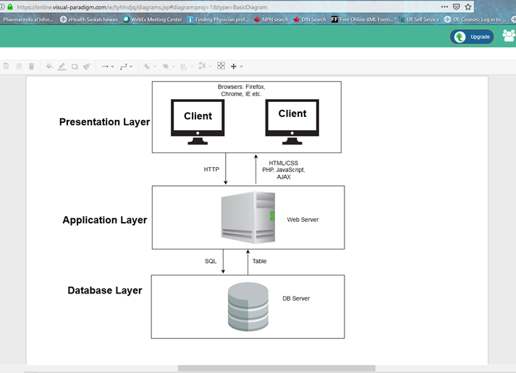

3.2 Sequence Diagrams

Use case 1: Creating a Post
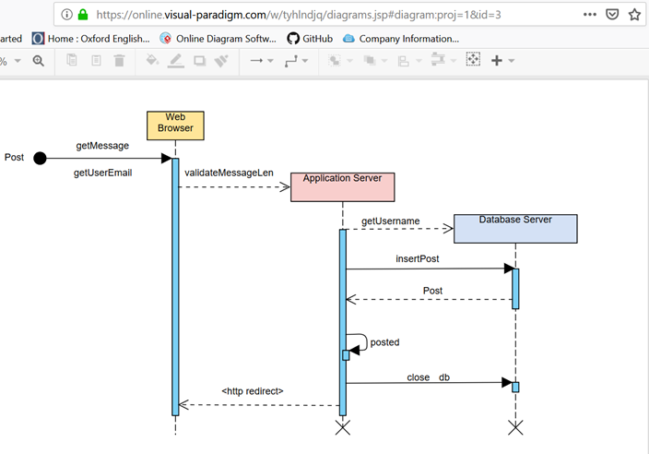

Use case 2: Viewing a Post
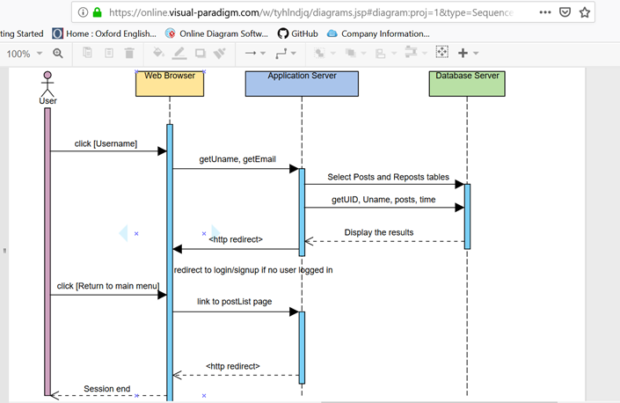

Use case 3: Reporting a Post
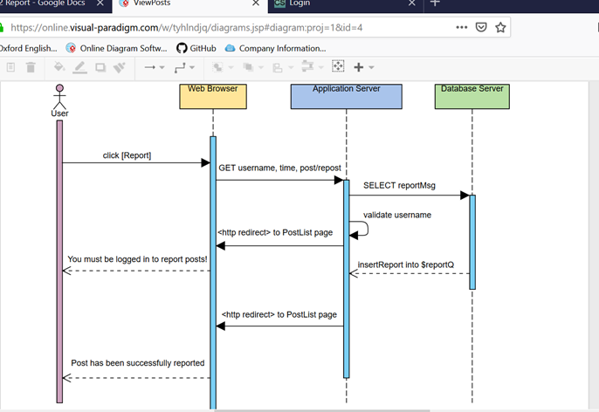

3.3 Class Diagrams
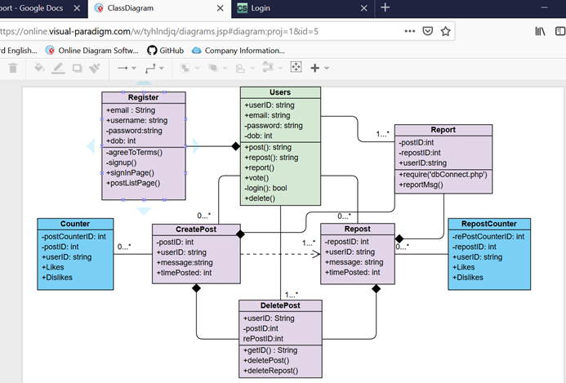

3.4 Object Diagrams

Example 1: Login Process
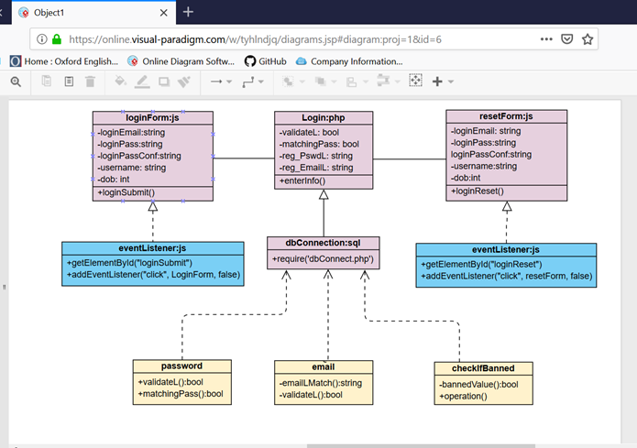

Example 2: Registration Process
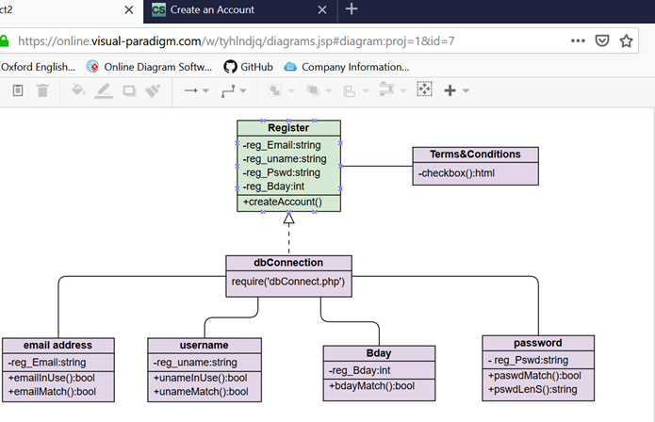

4. CODE
DESCRIPTION

4.1 Component Diagram
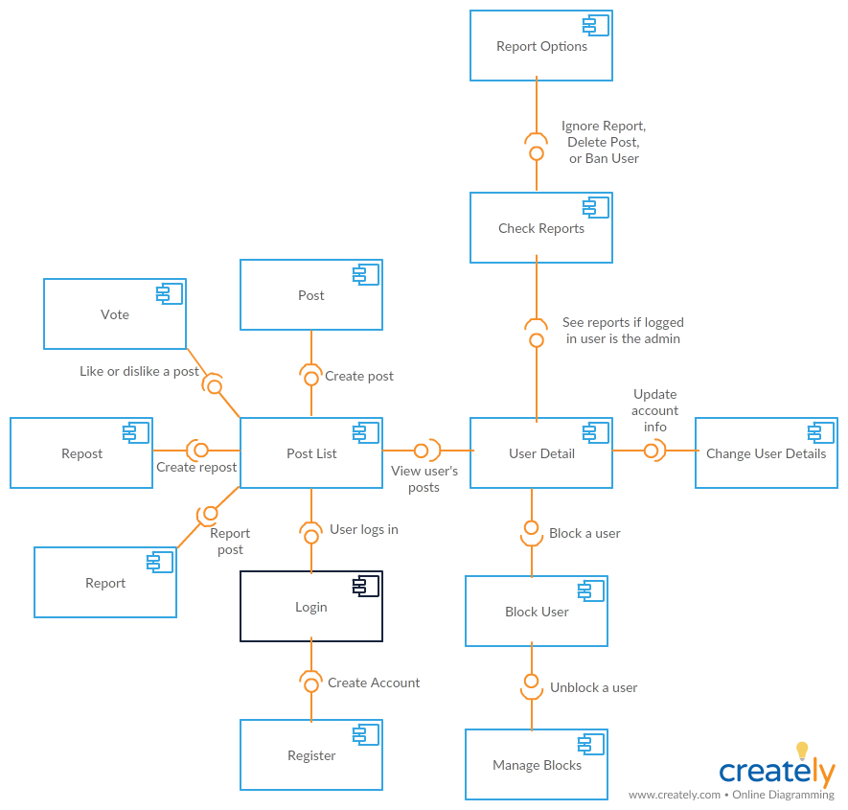

4.2 Deployment Diagram
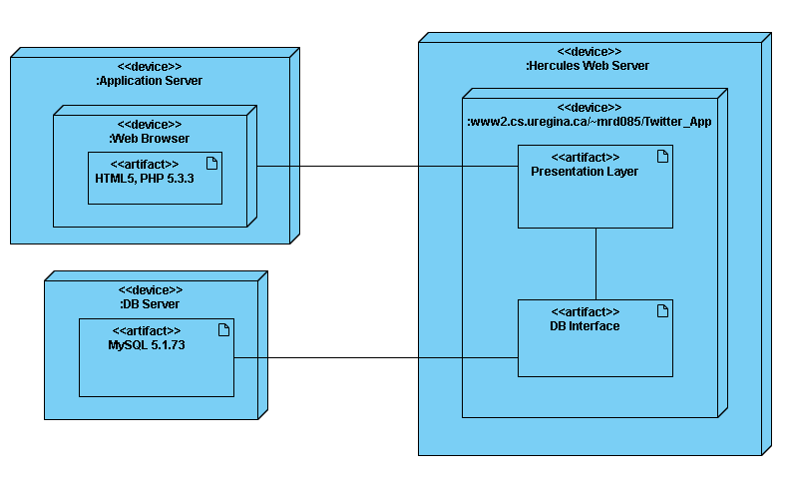

4.3 Classes and Functions Implemented
Class name | File Associated | Short Description
login | Login.php | Validates login actions, ensures correct format for inputs, sets session variable, etc.
register | Register.php | Validates register actions, ensures correct format for inputs, etc.
messages | displayMessages.php | Handles pulling posts from the database
sidebar | rightSide.php | Handles everything on the welcome screen once user is logged in
pageButtons | pageButtons.php | Handles switching between pages for every 20 posts
post | postClass.php | Handles the creation of posts and reposts
counter | counterClass.php | Handles increasing and decreasing the like/dislike counters
display | displayPosts.php | Handles displaying posts/reposts/reports on the PostList and UserDetail page (20 at a time).

4.4 Website URL
http://www2.cs.uregina.ca/~mrd085/Twitter_App/PostList.php

5. TECHINICAL
REQUIREMENTS

UML Supporting Tool

The UML supporting tools that were used for this software project are:

- Visual Paradigm Online which is an online diagram editor that allows for collaboration with team members.
Source: https://online.visual-paradigm.com/

- Creately which is a visual collaboration platform that allows users to create flowcharts, UML diagrams, mind maps, and more.
Source: https://creately.com/

Programming Languages

The programming languages that were used for this software project are:

- HTML (Hypertext Markup Language)
- HTML5
- XHTML1.1

- CSS (Cascading style sheets)

- PHP (Hypertext Preprocessor) – Server-side scripting language

- JavaScript: Client-side scripting language
- AJAX: Asynchronous JavaScript And XML
  - Note: AJAX is not a programming language but a tool that uses a browse built in XMLHttpRequest object with Javascript and HTML DOM to allow web pages to be updated asynchronously.

- SQL (Structured Query Language)

Reused Algorithms and Programs

The software did not use any programs and algorithms.

Software Tools and Environments
The software environments that were used for this project are:

  - Eclipse which is an open source Integrated Development Environment that was used to write, compile and edit HTML, PHP, JavaScript and CSS code for all pages of the website

  - Atom which is an open source text and code editor that was used to write, compile and edit HTML, PHP, JavaScript and CSS code for all pages of the website

  - Hercules which is a UNIX environment that was used to access, store and manage all HTML. PHP, JavaScript, CSS files and other necessary files for the project through a command-line interface

  - PuTTy which is a terminal emulation program that was used to connect to Hercules’s Command-Line on Windows for use of Hercules in locations off campus

  - WinSCP which is a SFTP and FTP client for Windows with a graphical user interface that was used to transfer files to and from Hercules

Database Management Systems

The database system that was used for this project is MySQL which implements Structured Query Language.

Screenshot of BlockList table, Counters table, and CounterUsers table:
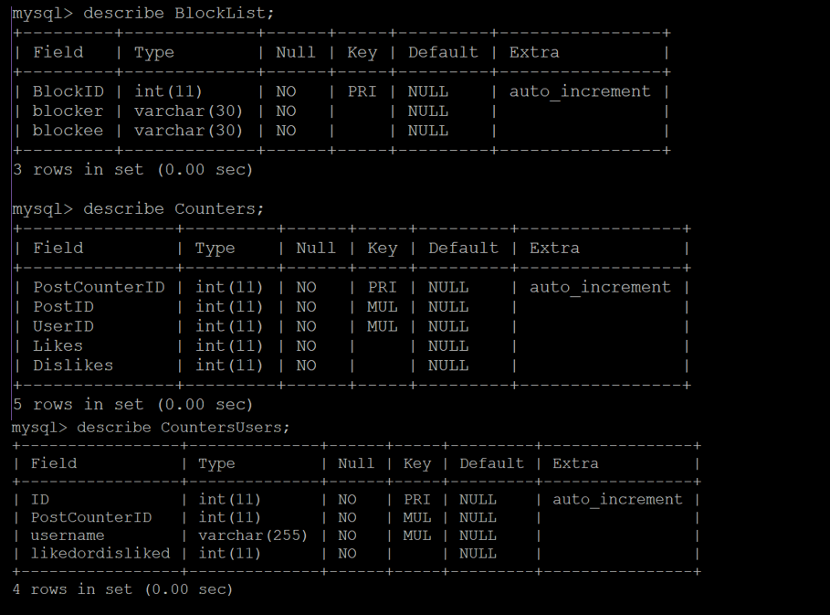

Screenshot of Posts table, Reports table, and RepostCounters table:
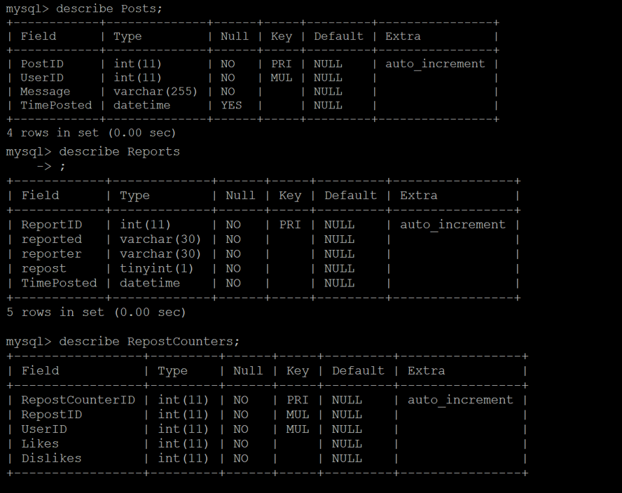
Screenshot of RepostCounterUsers table, Reposts table, and Users table:
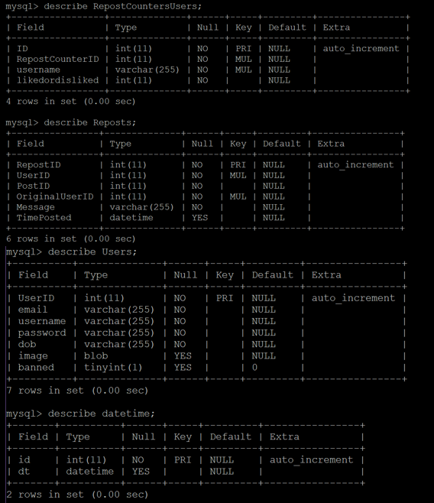

6. USER
DOCUMENTATION

User Creation
Creating a new user is simple! From the Login screen click on Register Here!

A new user account needs:
- An email address (something@something.something)
- Date of Birth in the format YEAR – DAY – MONTH (eg. 1972-22-05)
- A username
- A password, 8 characters minimum with at least one letter and one number
- A profile picture in JPG format

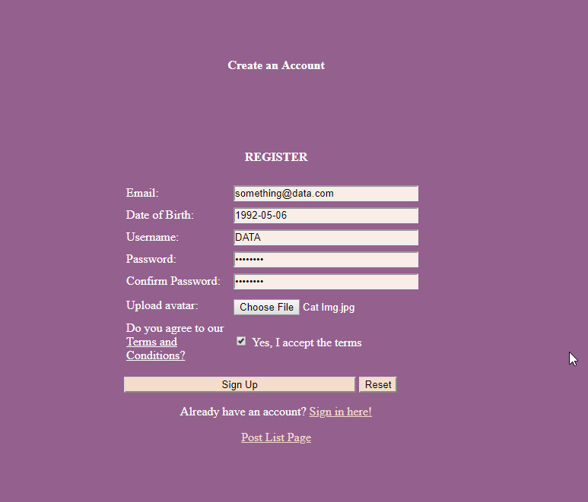

From there, simply agree to the terms (after hopefully reading them) and click Sign Up.

User Page
Your user page holds a wealth of options and information.

Here you can see your post history.
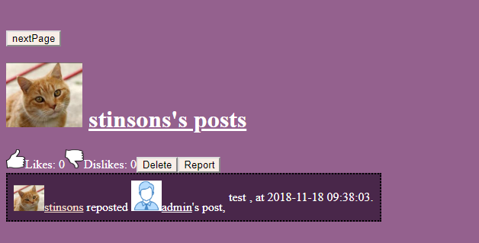

Add, Remove or Repost a previous post
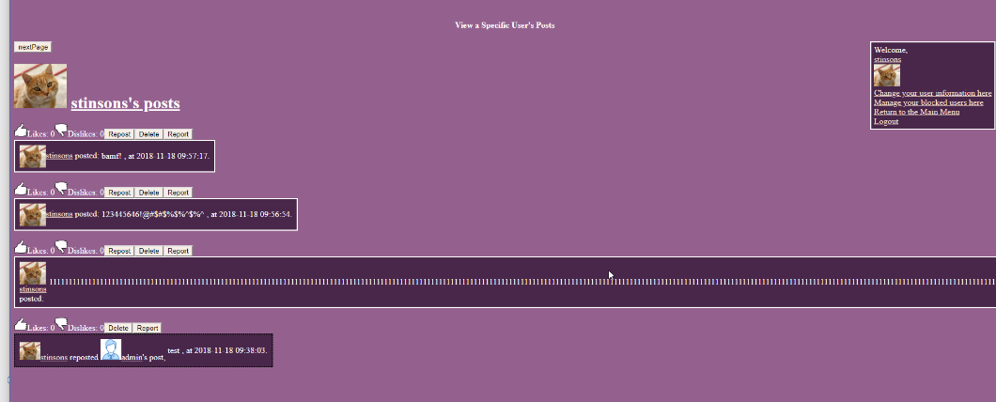

Or change your account information
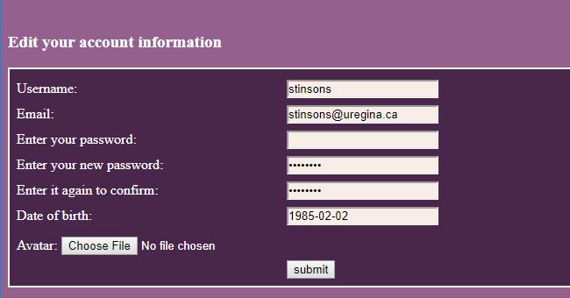

Post Creation
You’ve used social media, right? If so, then you’ve probably got this. From the main screen just click on the Create Post link at the top, left hand corner of the screen below our logo. 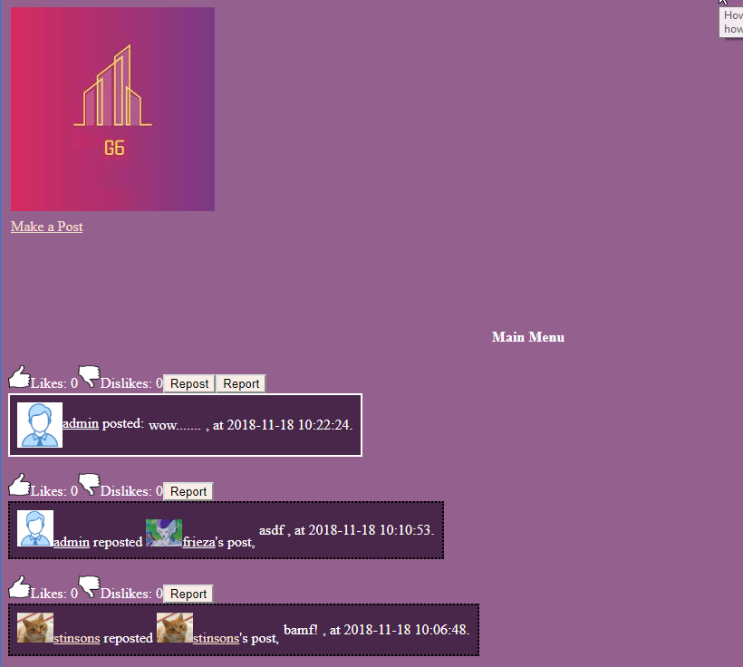

From here you can type away as you would on any of your favourite sites. We allow a roomy 250 characters, so you can speak your mind in comfort.
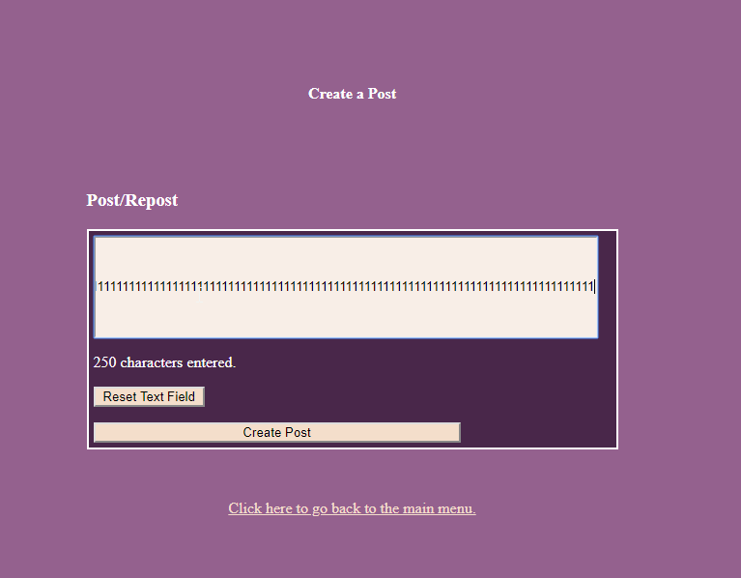

Where you’re done, your post will be seen on the main page.
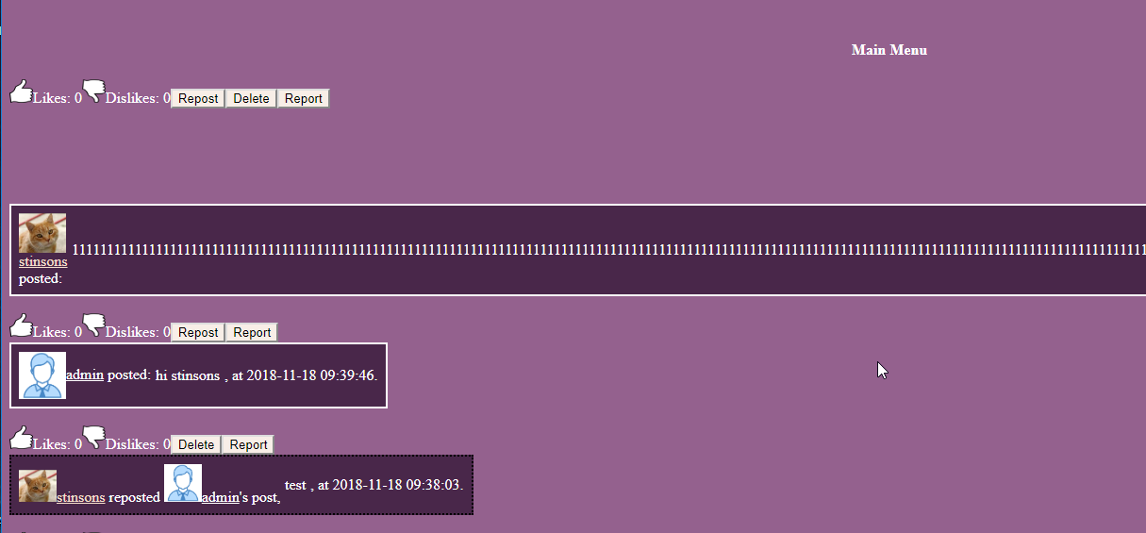

Post Voting and Reporting
Sometimes you want to give people a pat on the back. Sometimes you want to leave another message. Feedback is good! So here we’ve given you a few means with which to do just that.

Like or dislike a post with a click of a button
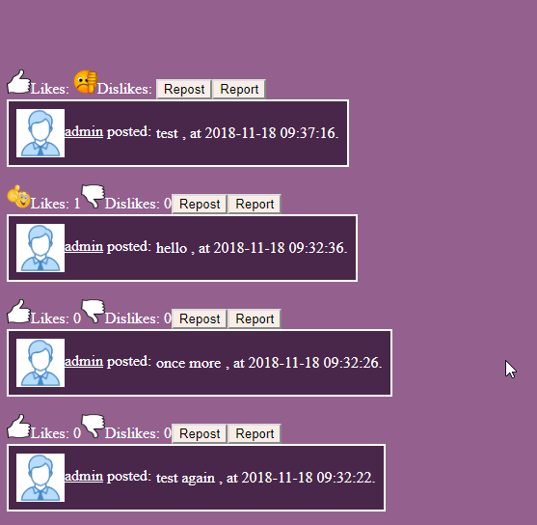

Repost content that you like to boost its popularity.
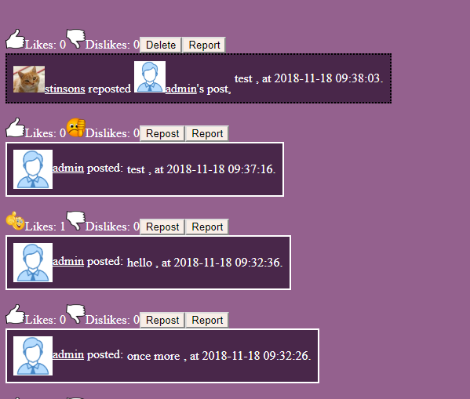

Report posts you think are inappropriate or abusive.
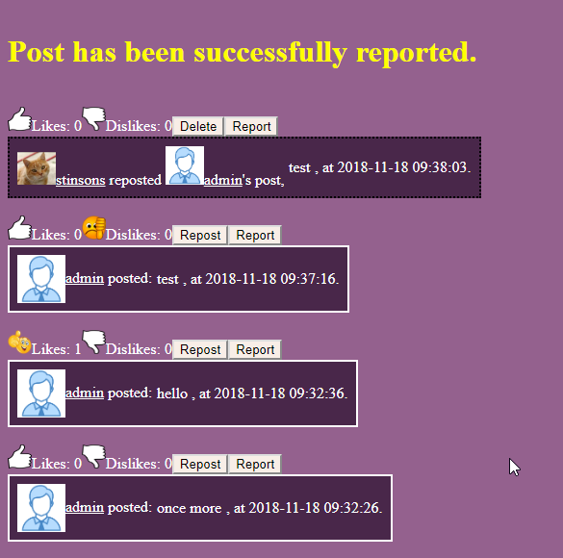

As a site administrator one has many ways of dealing with reports of inappropriate behavior.
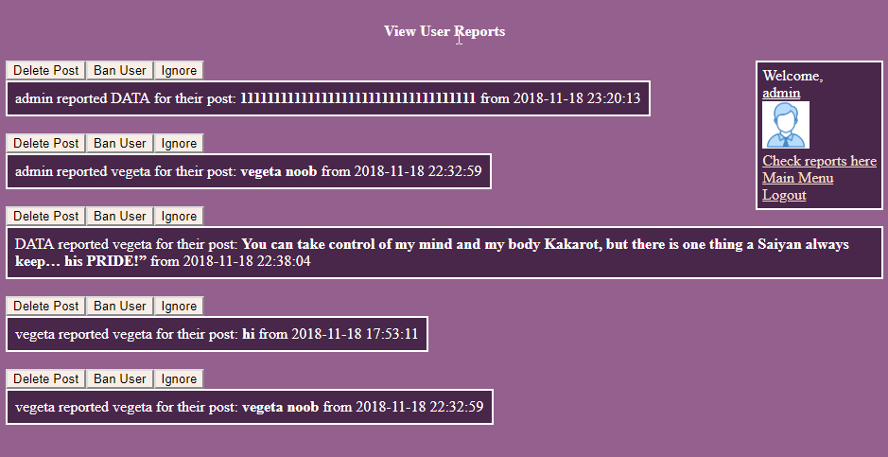

Admin may choose to Delete an offensive post, ban an especially negative user (deleting the post in question and preventing them from logging back into the site until they have contacted the site administrator), or merely ignore the report should the issue be deemed innocuous or unworthy of action.

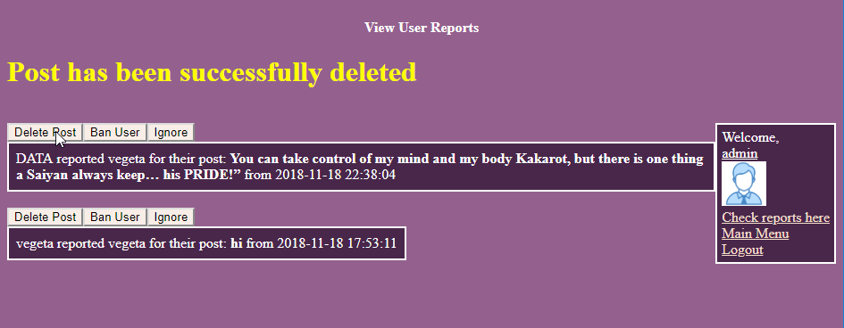

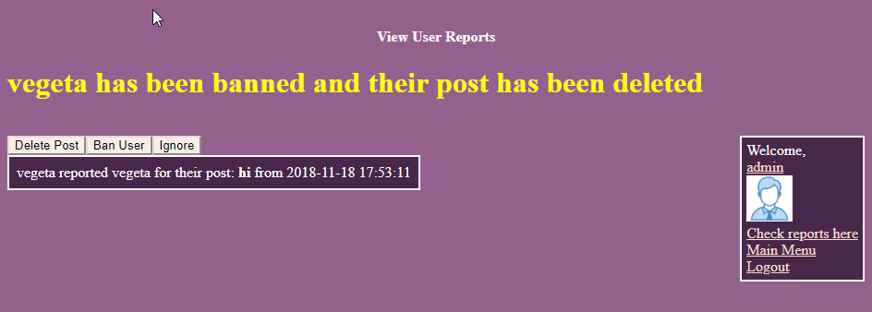

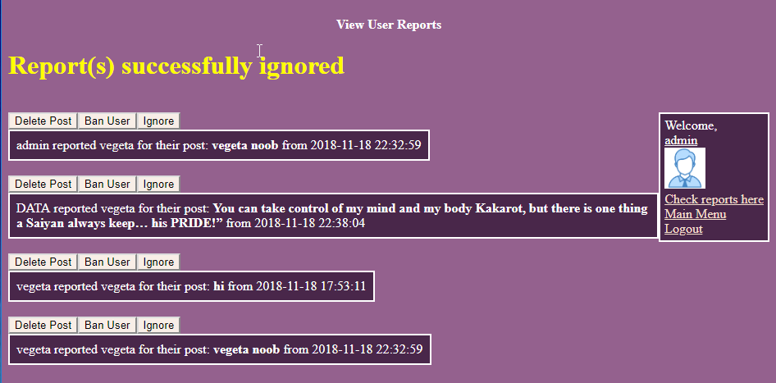

7. CODE
TESTING

7.1 Correctness Testing

Case 1: Can a user be created?

- Enter correct information types into fields

- Click Sign-up

- Enter Login Credentials
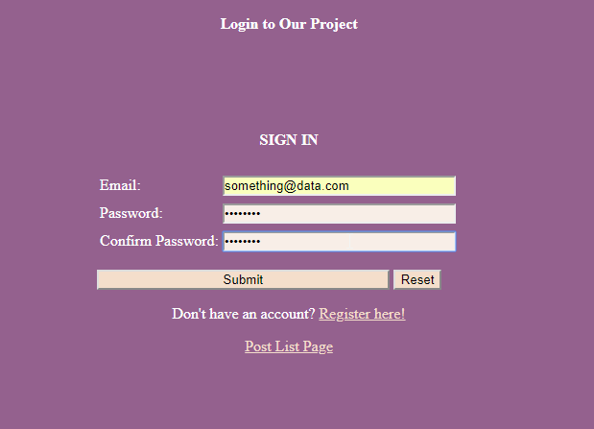

- Check if user now exists
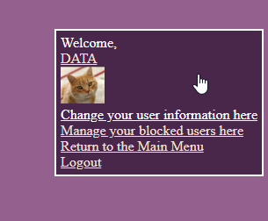

Case 2: Can a post be created?

    - Login as user

    - Type text into fields

    - Click Post

    - Post is now created

Case 3: Can user information be changed?
- Login as a user

- Go to Change your user information here

- Make required changes
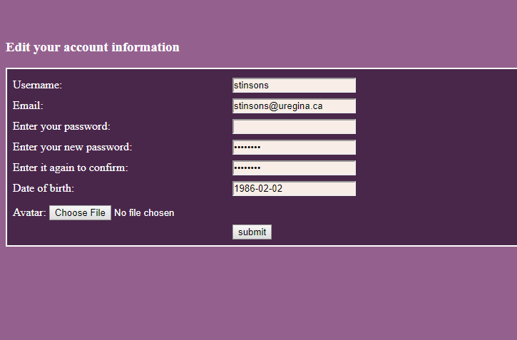

- Click Submit and verify that new information is accurate
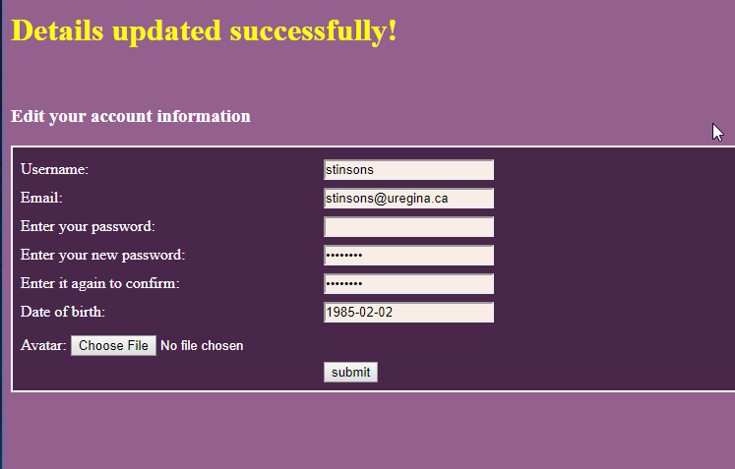

Case 4: Can users posts be seen?

Case 5: Can posts be disliked and liked?
- Navigate to main page
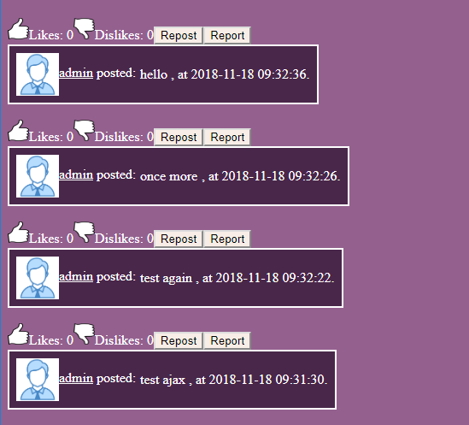

- Click on the like or dislike button

- Posts are appropriately marked

7.2 Robustness Testing

Case 1: JS Validation on User Creation
- Required fields are indicated
- Fields abide by the restrictions communicated to the user
- Required fields are needed before a user is created
- Appropriate error messages are displayed
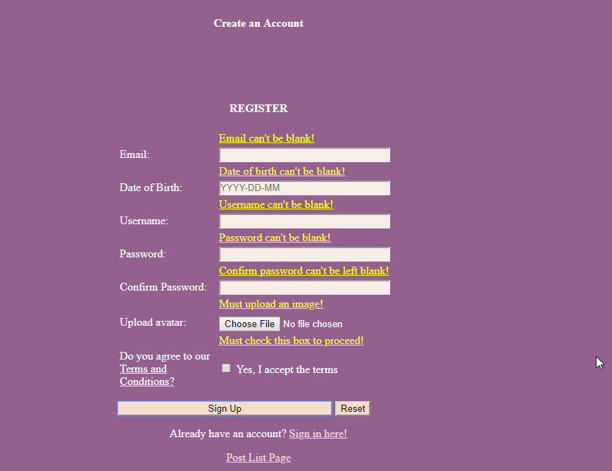

Case 2: JS Validation on Login
- Are required fields indicated
- Is Login prevented if necessary fields are missing/inaccurate?
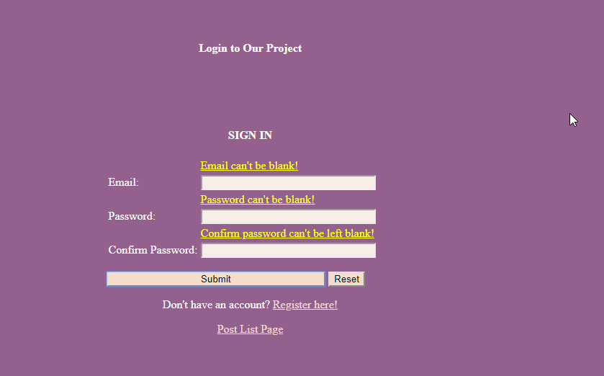

Case 3: Word Limit on Post
- A post of >250 cannot be typed
- A post of >250 cannot be posted
- Proper errors
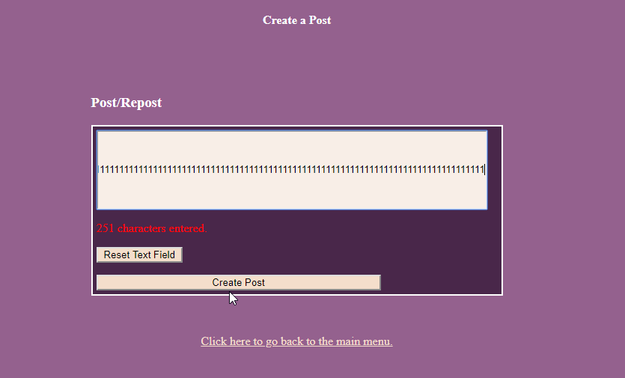

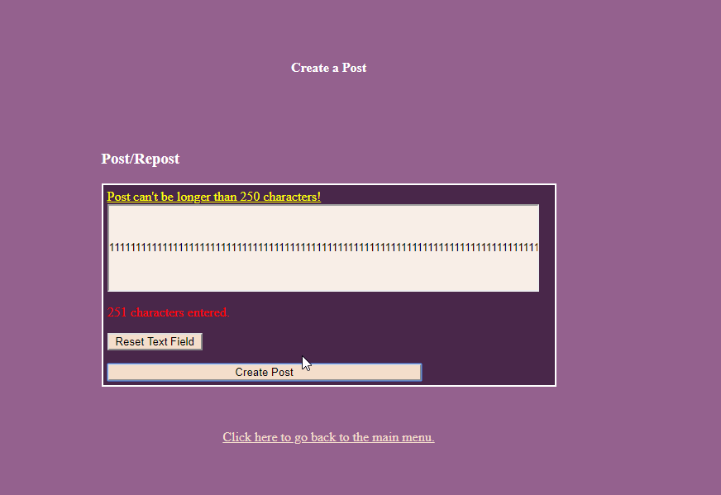

Case 4: Auto-Logout
- The user is automatically logged out after 2 minutes
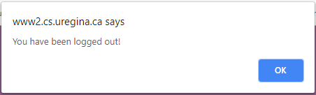
- After timeout user is returned to login screen and cannot perform any user specific functions until logging back in.

Case 5: JS Validation on User Information Change
- New photos must be .jpg
- New passwords must match
- A current password must be provided to change information
- Proper date format must be observed
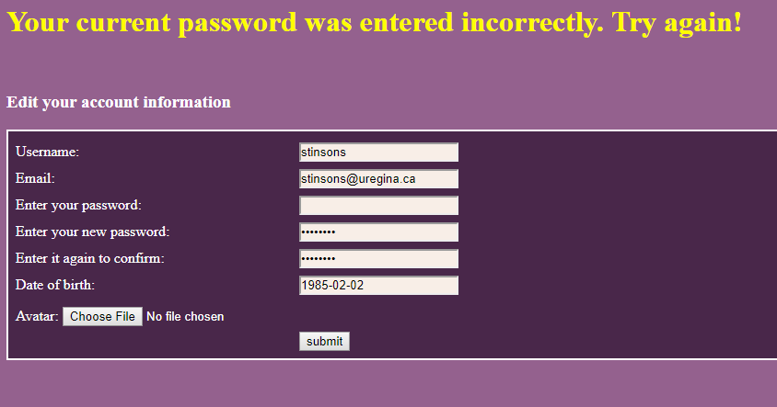

7.3 Performance Testing

Testing on Different Devices
- App has been tested on Chrome, Firefox, and Edge
- App has been tested for visibility on desktop and mobile devices (phone screenshots shown below)
- Upper bound for posts is limited by SQL Database allocated by U of R
- No performance issues seen with multiple users accessing/interacting with app
- No perceptible issues (data collisions) seen with multiple users accessing the same post for editing (upvote/downvote/repost)

Screenshots of website on Android phone
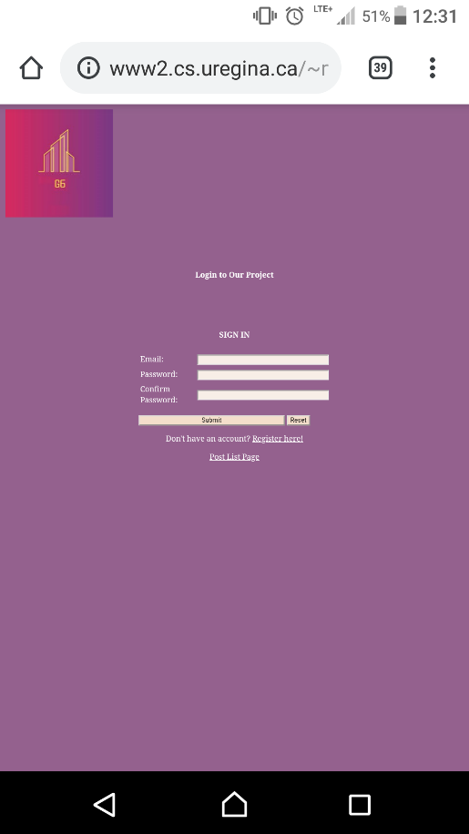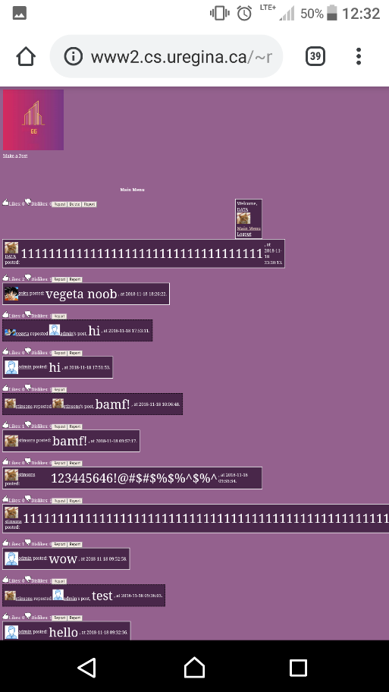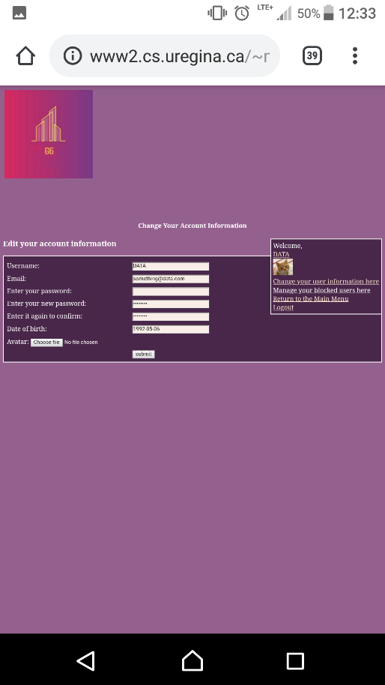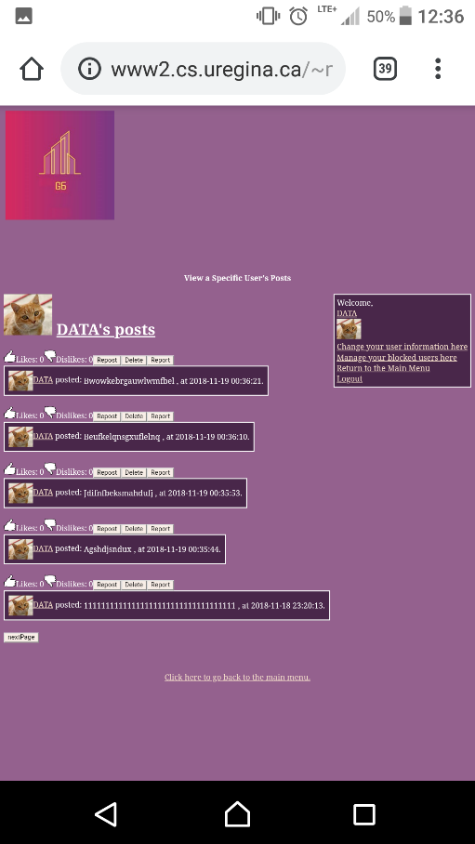

8. MEMBER
CONTRIBUTIONS

8. MEMBER
CONTRIBUTIONS

8. MEMBER
CONTRIBUTIONS

8. MEMBER
CONTRIBUTIONS

8. MEMBER
CONTRIBUTIONS

8. MEMBER
CONTRIBUTIONS

8. MEMBER
CONTRIBUTIONS

8. MEMBER
CONTRIBUTIONS

8. MEMBER
CONTRIBUTIONS

8. MEMBER
CONTRIBUTIONS

8. MEMBER
CONTRIBUTIONS

8. MEMBER
CONTRIBUTIONS

8. MEMBER
CONTRIBUTIONS

8. MEMBER
CONTRIBUTIONS

8. MEMBER
CONTRIBUTIONS

8. MEMBER
CONTRIBUTIONS

Shannon
During this project Shannon contributed to the planning and project proposal sessions, provided some basic functional and robustness testing, and created the user documentation seen above. She also assisted on some research into the code augmentation (auto-logout functionality) and participated in group feedback sessions along the development of this project.

Mahrukh
Mahrukh attended and engaged in the group meetings in which discussions regarding the project proposal, member duties and steps to complete the project report took place. For the project report, she worked on the problem definition, the uses case descriptions needed for the software requirements, software qualities, and the sections under technical documentation. She also designed, edited, and organized the final report.

